Emre Can Şen- 21902516

Section-2

Lab-06

Analytical Part

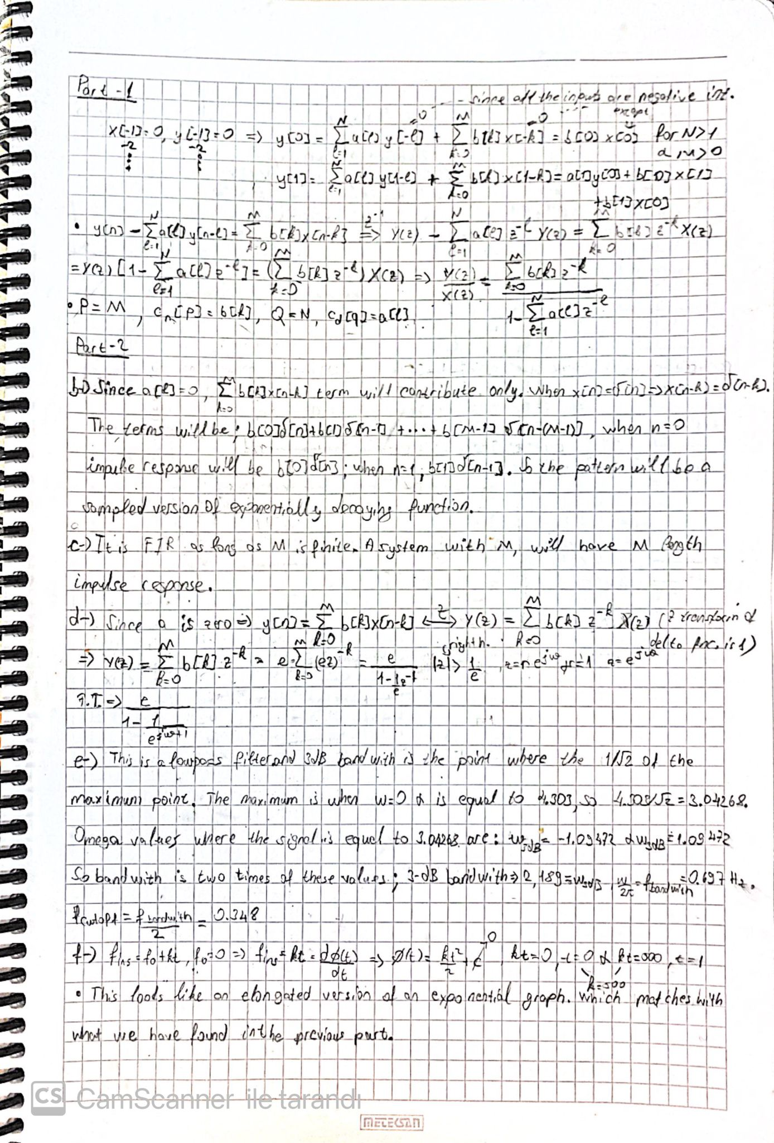

Figure 1- Analytical Part 1

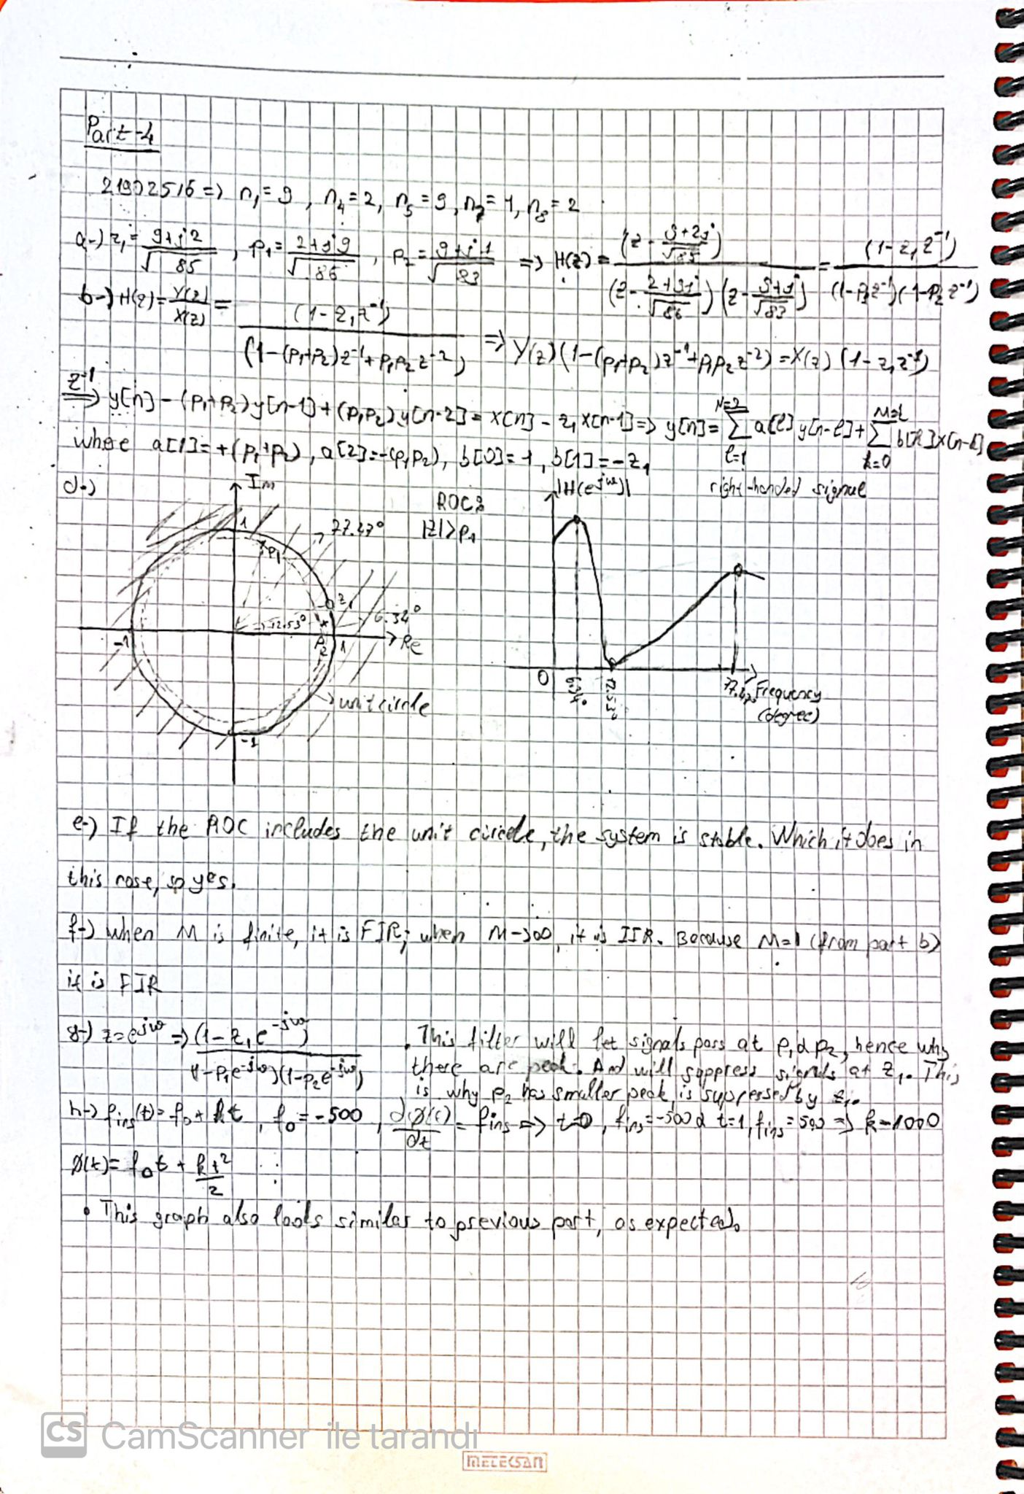

Figure 2- Analytical Part 2

Plots

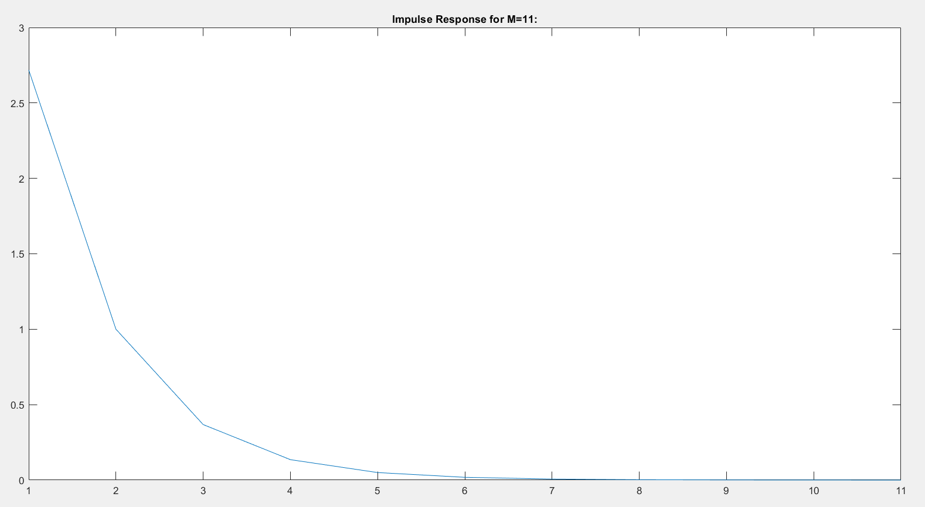

Figure 3- Impulse Response

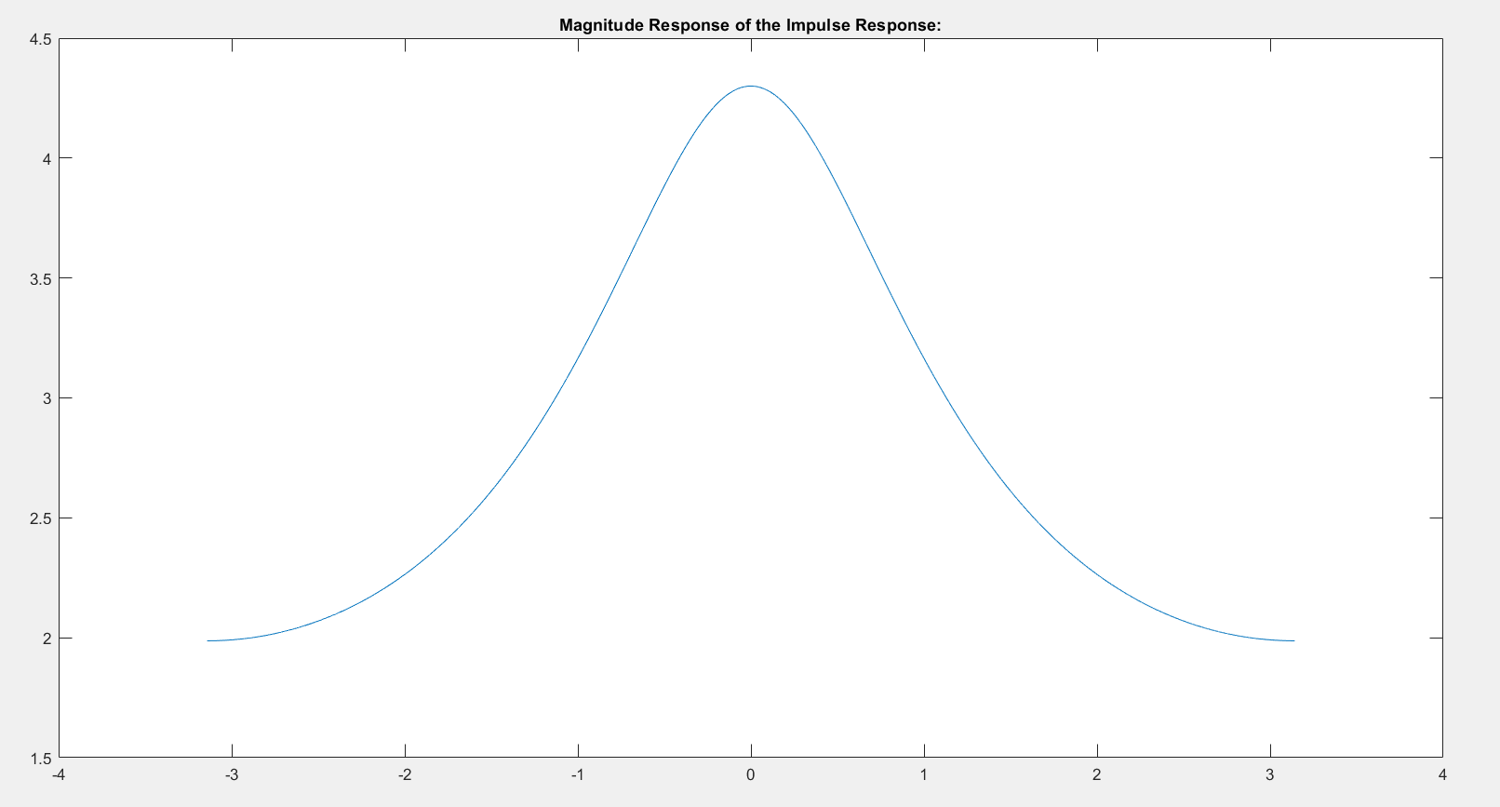

Figure 4- Magnitude Response of Impulse Response

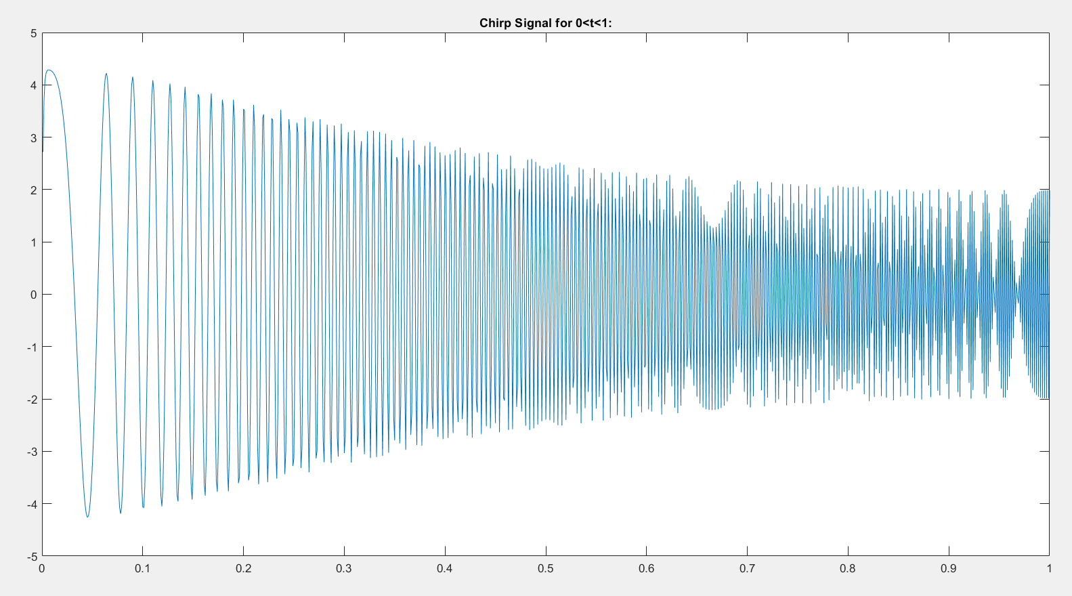

Figure 5- Chirp Signal 1

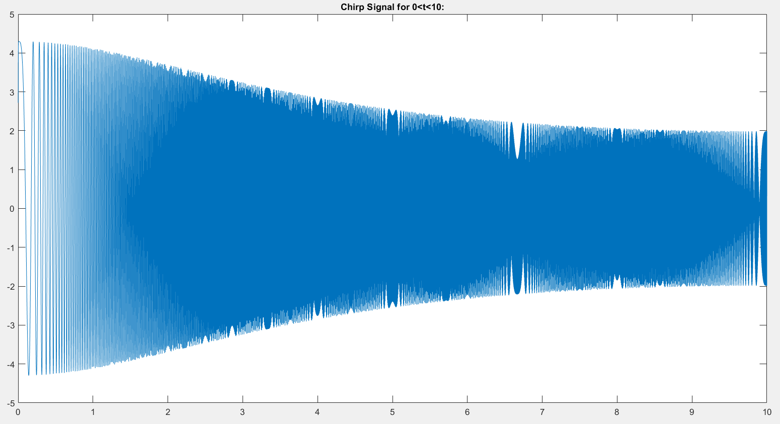

Figure 6- Chirp Signal 2

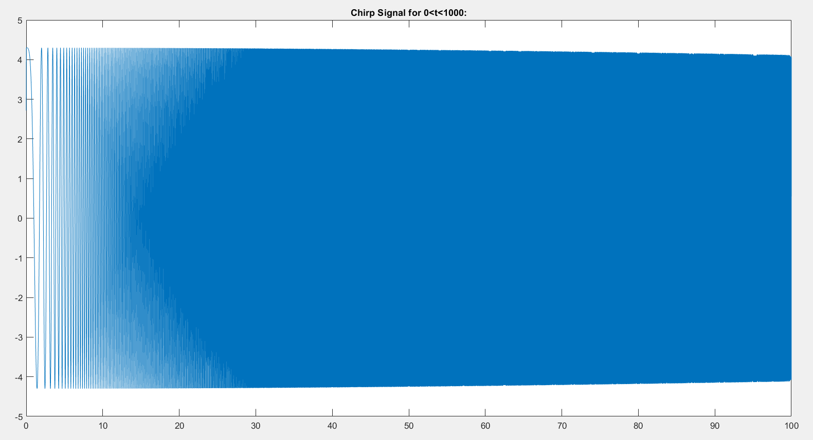

Figure 7- Chirp Signal 3

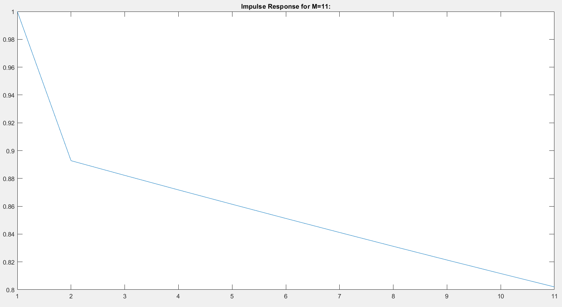

Figure 8- Impulse Response of Part 4

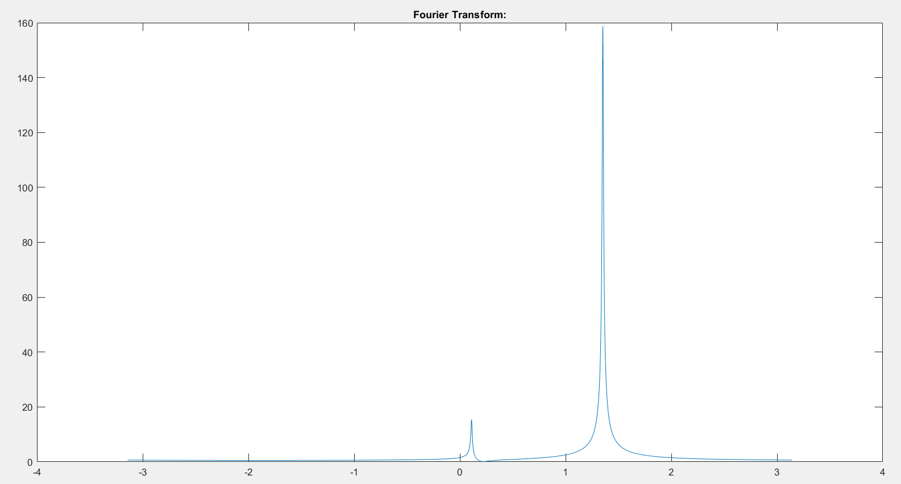

Figure 9- Fourier Transform Magnitude Plot

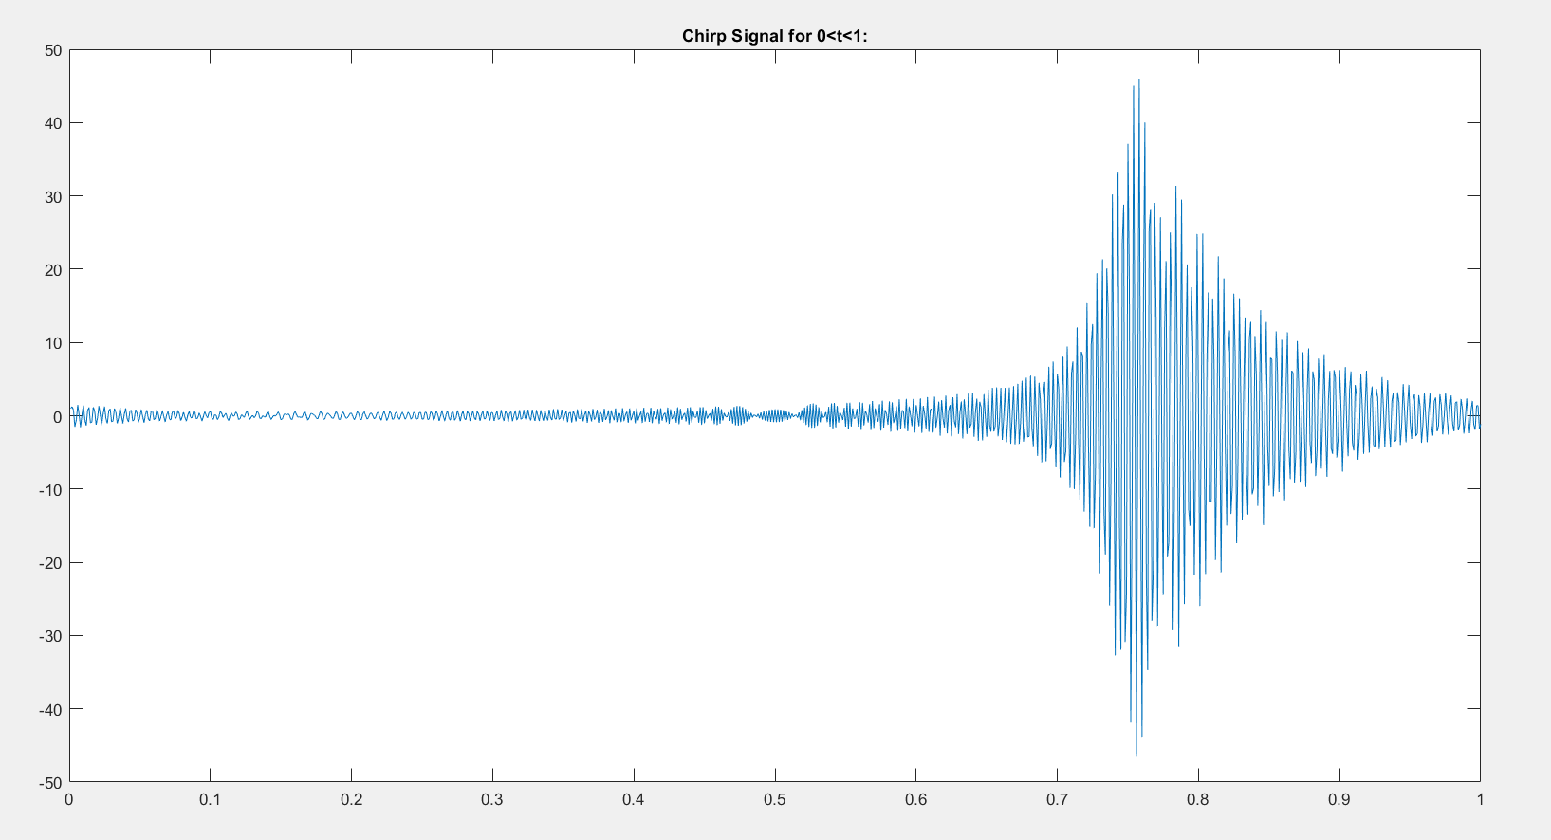

Figure 10- Chirp Signal 1

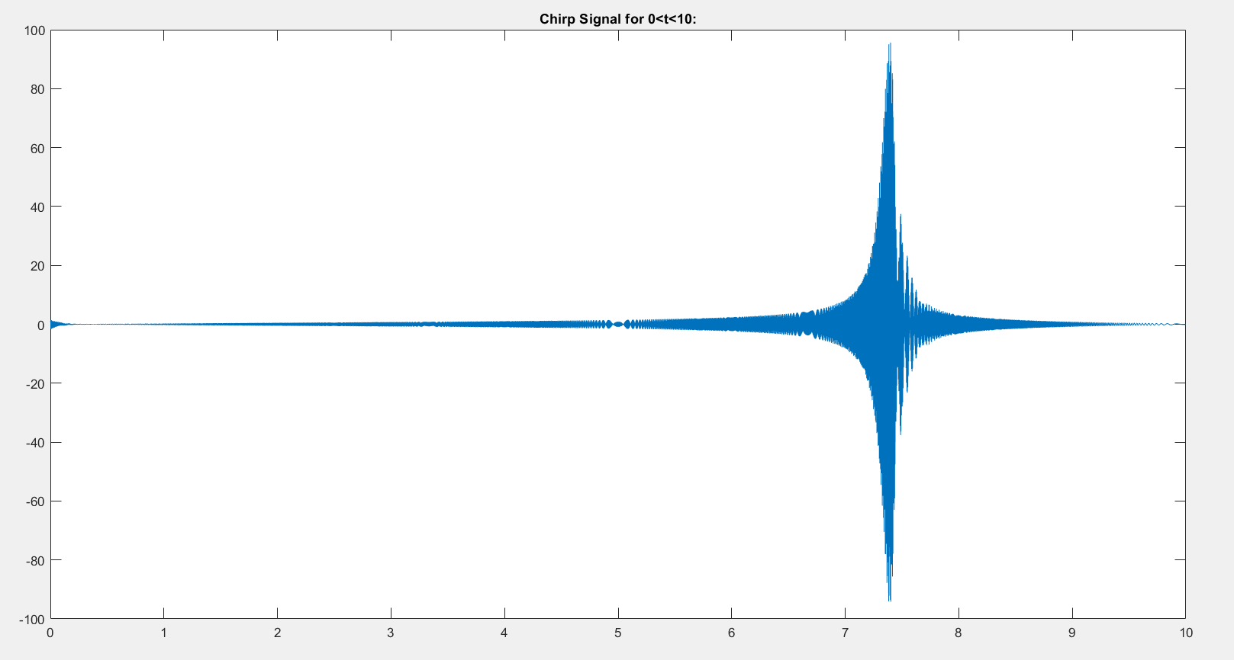

Figure 11- Chirp Signal 2

MATLAB Code

M=11;

a=zeros(1,11);

b=[];

for l=1:M

newval=exp(-1*(l-1)+1);

b(l)=newval;

end

x_init0=1:11;

y0=[];

y0=DTLTI(a,b,[1 0 0 0 0 0 0 0 0 0 0],11);

figure(1)

plot(x_init0,y0)

title('Impulse Response for M=11:')

figure(2)

omega=-1*pi:1/8192:pi;

mag_imp=exp(1)./(1-exp(-1i*omega-1));

plot(omega,abs(mag_imp))

title('Magnitude Response of the Impulse Response:')

figure(3)

x_t=0+0.001:1/1000:1;

k=500;

a=zeros(1,length(x_t));

M=length(x_t);

for l=1:M

newval=exp(-1*(l-1)+1);

b(l)=newval;

end

x_t0=cos(pi*k*(x_t).^2);

y_chirp=DTLTI(a,b,x_t0,length(x_t));

plot(x_t,y_chirp)

title('Chirp Signal for 0<t<1:')

figure(4)

x_t=0+0.001:1/1000:10;

k=50;

a=zeros(1,length(x_t));

M=length(x_t);

for l=1:M

newval=exp(-1*(l-1)+1);

b(l)=newval;

end

x_t0=cos(pi*k*(x_t).^2);

y1_chirp=DTLTI(a,b,x_t0,length(x_t));

plot(x_t,y1_chirp)

title('Chirp Signal for 0<t<10:')

figure(5)

x_t=0+0.001:1/1000:1000;

k=1/2;

a=zeros(1,length(x_t));

M=length(x_t);

for l=1:M

newval=exp(-1*(l-1)+1);

b(l)=newval;

end

x_t0=cos(pi*k*(x_t).^2);

y2_chirp=DTLTI(a,b,x_t0,length(x_t));

plot(x_t,y2_chirp)

title('Chirp Signal for 0<t<1000:')

figure(6)

x_init1=1:11;

a1=[((2+9i)/sqrt(86)+(9+1i)/sqrt(83)) -((2+9i)/sqrt(86)*(9+1i)/sqrt(83)) 0 0 0 0 0 0 0 0 0];

b1=[1 -(9+2i)/sqrt(85) 0 0 0 0 0 0 0 0 0];

y1=DTLTI(a1,b1,[1 0 0 0 0 0 0 0 0 0 0],11);

plot(x_init1,abs(y1))

title('Impulse Response for M=11:')

figure(7)

mag_sec=(1-(9+2i)*exp(-1i*omega)/sqrt(85))./((1-(2+9i)*exp(-1i*omega)/sqrt(86)).*(1-(9+1i)*exp(-1i*omega)/sqrt(83)));

plot(omega,abs(mag_sec))

title('Fourier Transform:')

figure(8)

x_t=0+0.001:1/1000:1;

k=1000;

a1=zeros(1,length(x_t));

a1(1)=((2+9i)/sqrt(86)+(9+1i)/sqrt(83));

a1(2)=-((2+9i)/sqrt(86)*(9+1i)/sqrt(83));

b1=zeros(1,length(x_t));

b1(1)=1;

b1(2)=-(9+2i)/sqrt(85);

x_t0=exp(1i*2*pi*k*(1/2*(x_t).^2+-500*x_t));

y3_chirp=DTLTI(a1,b1,x_t0,length(x_t));

plot(x_t,y3_chirp)

title('Chirp Signal for 0<t<1:')

figure(9)

x_t=0+0.001:1/1000:10;

k=100;

a1=zeros(1,length(x_t));

a1(1)=((2+9i)/sqrt(86)+(9+1i)/sqrt(83));

a1(2)=-((2+9i)/sqrt(86)*(9+1i)/sqrt(83));

b1=zeros(1,length(x_t));

b1(1)=1;

b1(2)=-(9+2i)/sqrt(85);

x_t0=exp(1i*2*pi*k*(1/2*(x_t).^2+-500*x_t));

y4_chirp=DTLTI(a1,b1,x_t0,length(x_t));

plot(x_t,y4_chirp)

title('Chirp Signal for 0<t<10:')

figure(10)

x_t=0+0.001:1/1000:1000;

k=1;

a1=zeros(1,length(x_t));

a1(1)=((2+9i)/sqrt(86)+(9+1i)/sqrt(83));

a1(2)=-((2+9i)/sqrt(86)*(9+1i)/sqrt(83));

b1=zeros(1,length(x_t));

b1(1)=1;

b1(2)=-(9+2i)/sqrt(85);

x_t0=exp(1i*2*pi*k*(1/2*(x_t).^2+-500*x_t));

y5_chirp=DTLTI(a1,b1,x_t0,length(x_t));

plot(x_t,y5_chirp)

title('Chirp Signal for 0<t<1000:')

function y=DTLTI(a,b,x,Ny)

y=zeros(1,Ny);

N=1:Ny;

T0=(1==N);

T=(2<=N & N<=Ny);

y(T0)=b(T0).*x(T0);

if Ny> 1

for Ny=1:Ny

n=Ny-1;

x_holder=0;

y_holder=0;

for initializer=[1:Ny]

initializer0=n-initializer+2;

x_holder=x_holder+b(initializer).*x(initializer0);

end

if n==1

y_holder=a(1).*y(1);

else

for initializer=[1:Ny-1]

initializer0=n-initializer+2;

y_holder=y_holder+a(initializer).*y(initializer0);

end

end

y(N==n+1)=x_holder+y_holder;

end

end

end